Benha University, Faculty of Science Entomology Department

Midterm, 2nd Semester, 2016, General Entomology2 (112E)

Time allowed 30 Minutes

- Complete the missing parts in the following figures

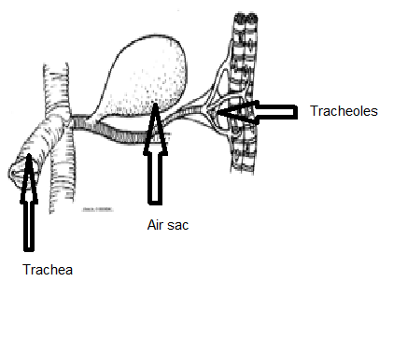

- Discus the following statement: Some species of insects are able to reproduce asexually.
Some species of insects as Aphids can reproduce asexually by a phenomena known as Parthenogensis ( virgin females produce new individuals)
- Write on: Diaphragms and sinuses in hemolymph circulation in insects
To facilitate circulation of hemolymph, the body cavity is divided into three compartments (called blood sinuses which are dorsal, ventral and periveseral sinuses) by two thin sheets of muscle and/or membrane known as the dorsal and ventral diaphragms. The dorsal diaphragm is formed by alary muscles of the heart and related structures. The ventral diaphragm usually covers the nerve cord.

